Clarity: -
- Who is the user? (one type only)
Ans. Developer

- What is the main problem? (one sentence)
Ans. It too time consuming and complex to build softwares.

- What does success look like?
Ans. User can gets its project by writing a simple prompt and code is generated and it is validated by tester.

Workflow: -

- Raw: -
- User writes prompt
- Planner agent plans the project.
- Developer agent develops the code.
- Tester test the code and if some error occur send its output to developer.
- Observer analysis the code and see if all requirements are completed and if not then it goes to developer.

- Flow diagram: -

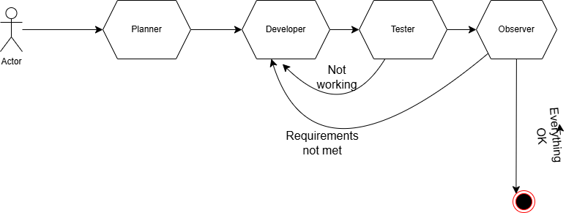

Version 1 : -

- What needs to be included?
- All agents are connected and call each other.
- Projects should be made in single python.

- What success looks like?
It provides me a single py file according to my prompt.

